|  |
| --- |
| South Africa Livelihood Zone Profile  59101 – Lowveld Open Access Cattle and Other Income (*ZALOC*) |
| Zone Description |

This livelihood zone is located in the lowveld where growing crops is difficult. It consists of four main sections:

Figure 1: Map of the livelihood zone

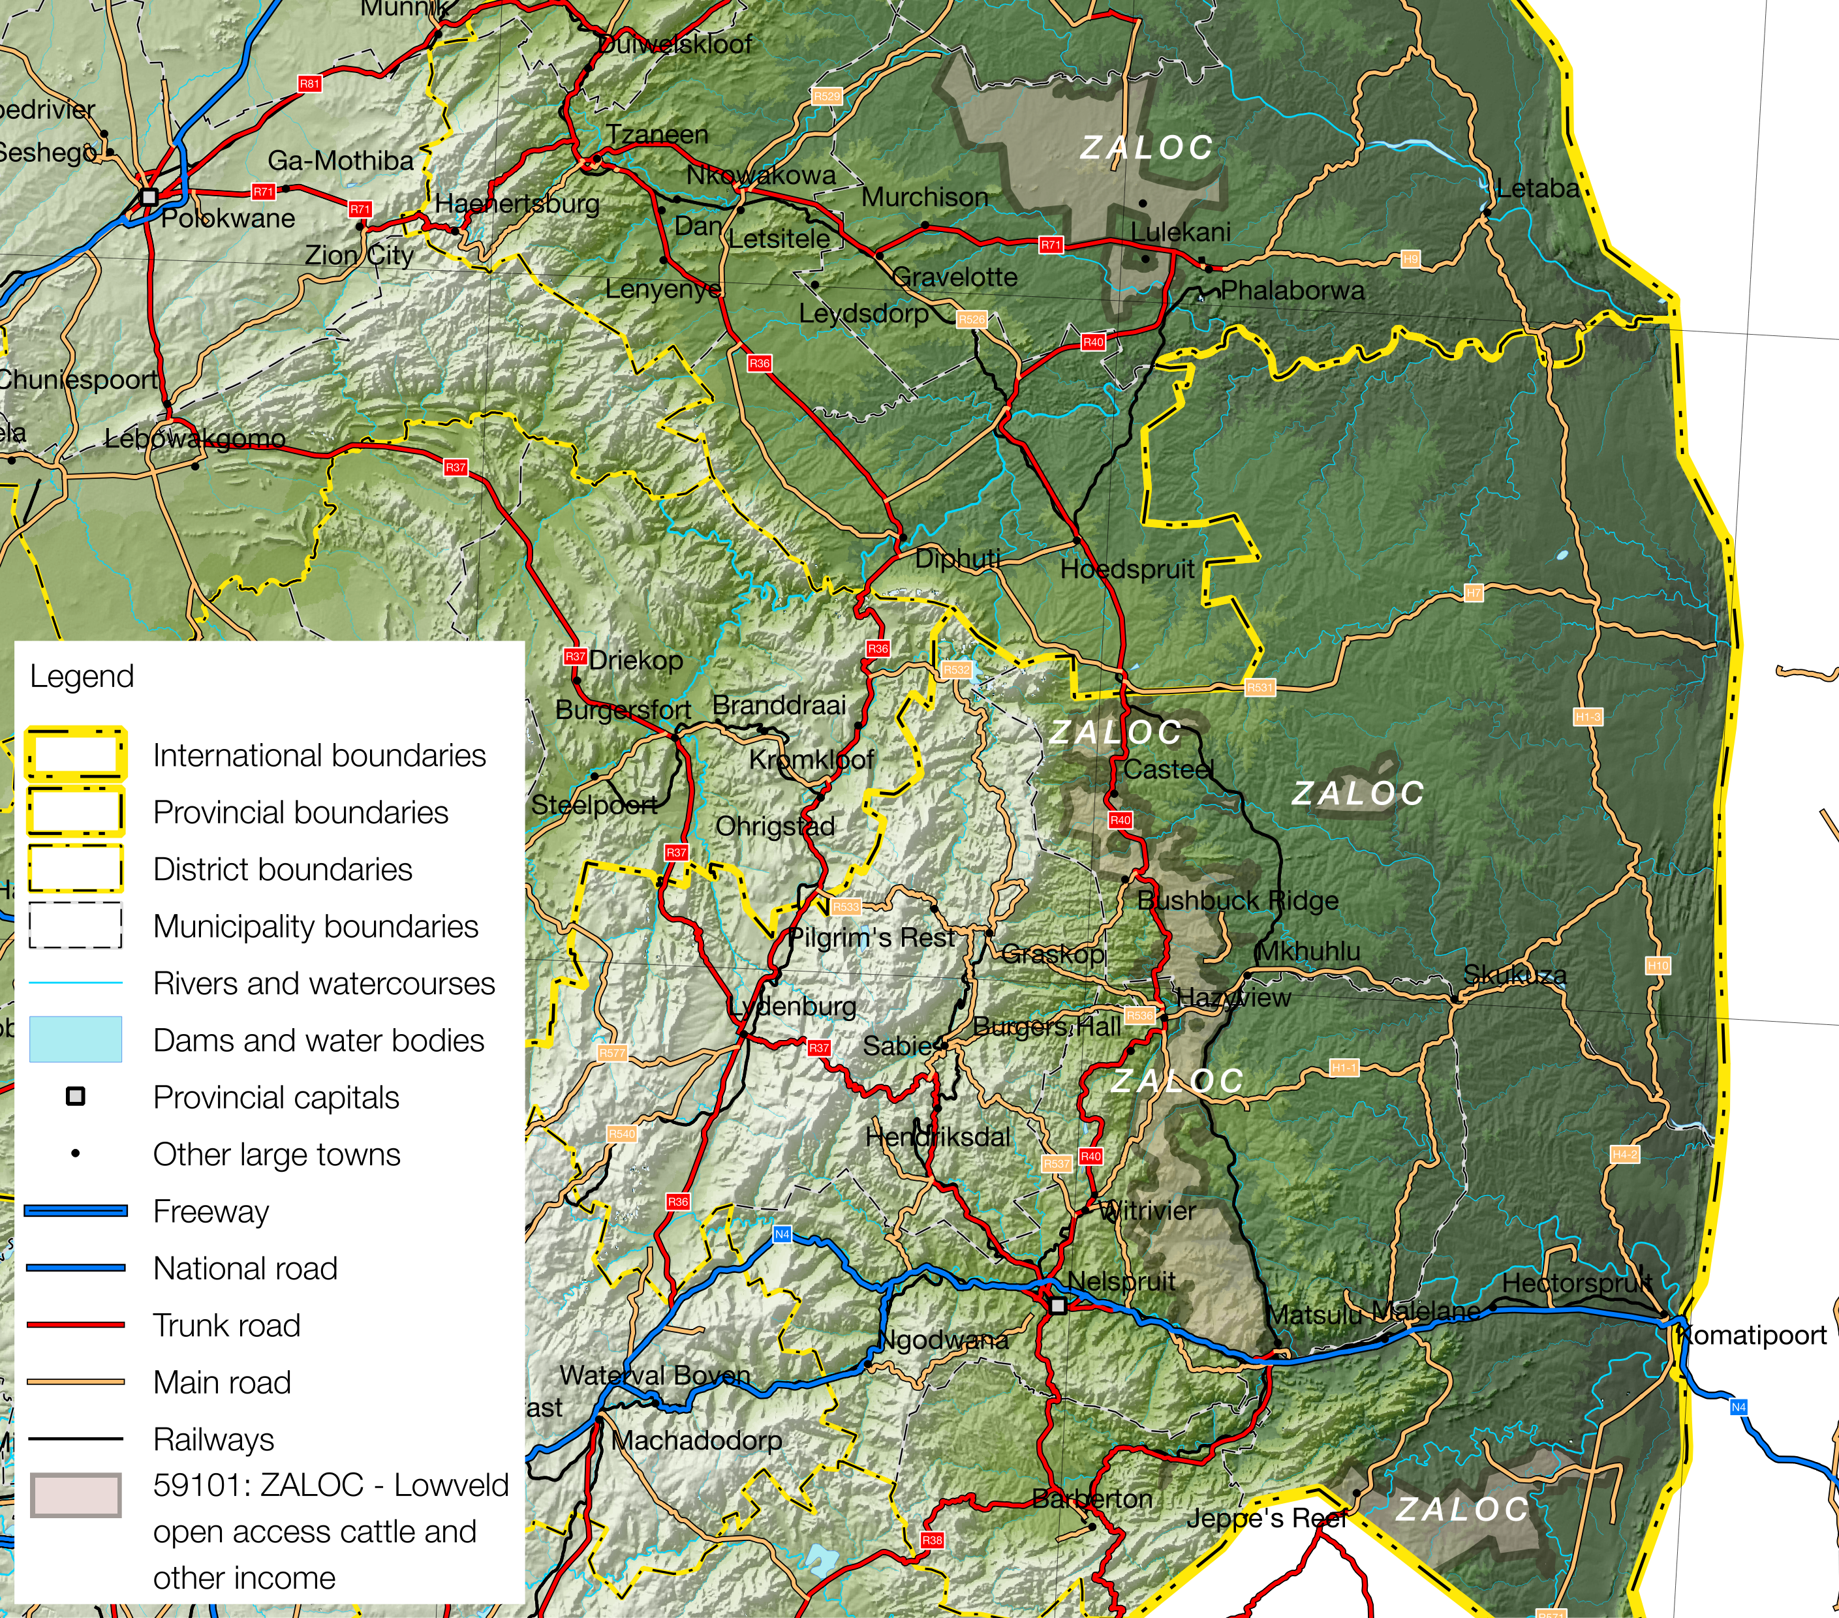

Projection: Albers Equal Area with Standard Parallels at 22.67 S and 24.88 S, Longitude of Centre at 29.29 E.

Sources of data: Open Street Map, Highways (<http://wiki.openstreetmap.org/wiki/Planet.osm>) for the road lines, Shuttle Radar Topography Mission (SRTM) 3 version 2.1 (<http://www2.jpl.nasa.gov/srtm/>) for the elevation and relief shading and Agricultural Geo-referenced Information System (AGIS)

* The section to the west of Ba-Phalaborwa, which stretches up to the Greater Giyani border.
* A narrow section on a north-south axis running from the Limpopo border through Bushbuckridge as far as the N4 in Mbombela Municipality in Mpumalanga;
* An ‘island’ around the village of Uthla, adjacent to the game reserves in Bushbuckridge Municipality; and

Figure 2: Livelihood zone location

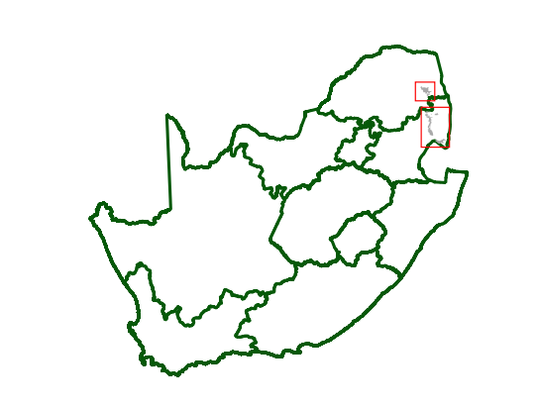

* A section between the Lomati and Komati Rivers in Nkomazi Municipality.

Much the zone is well-watered: the Ba-Phalaborwa section is the driest, receiving 400 to 600 mm of rain annually; while the Bushbuckridge and Mbombela sections are the wettest, receiving 600 to 1,000 mm; and the Nkomazi section receives 600 to 800 mm annually. Despite the high rainfall, the land is marginal for crop (especially maize) production. This is a densely populated livelihood zone when compared with its neighbours, so wealthier households are formally employed or own a small business, while poorer households depend on petty trading, casual labour and grants. The wealthy may keep cattle, which graze the surrounding veld.

Table 1 - 2016 Population breakdown of districts and municipalities covered by the livelihood zone, based on the 2011 Census and annual projections

|  |  |  |  |  |
| --- | --- | --- | --- | --- |
| **Province** | **District** | **Municipality** | **Pop. Est. in ZALOC** | **% of Admin Level** |
| Limpopo | Mopani | Ba-Phalaborwa | 67,385 | 41.99% |
| **Provincial Total** | | | **67,385** | **1.16%** |
| Mpumalanga | Ehlanzeni | Bushbuckridge | 227,103 | 40.23% |
| Mbombela | 373,569 | 60.85% |
| Nkomazi | 144,647 | 35.30% |
| Umjindi | 1,676 | 2.44% |
| **Provincial Total** | | | **746,995** | **17.15%** |

Source: Statistics South Africa, Census 2011 small area population data and district population projections

**Figure** is a map of the zone and  **Figure** shows the location. The Ba-Phalaborwa section is served by the R71 and the R40, while the Bushbuckridge and Mbombela sections are served by the R40 and N4 highways. Both these two sections also have railways: a branch line from Nelspruit to Phalaborwa and the line that parallels the N4 from Gauteng to Maputo via Nelspruit. The Nkomazi section is served by the R570 and a feeder road from the R571; both these two roads originate from the N4 between Nelspruit and Komatipoort. The R570 crosses the Swazi border at Jeppe’s Reef.

The livelihood zone has been given an alphabetic code (or abbreviation) of 'ZALOC' and a numeric code of 59101. These codes distinguish the zone both nationally and internationally, as well as allowing zone name changes and updates if desired (the code should always remain the same).

Figure 3: Gender and age breakdown of the zone population

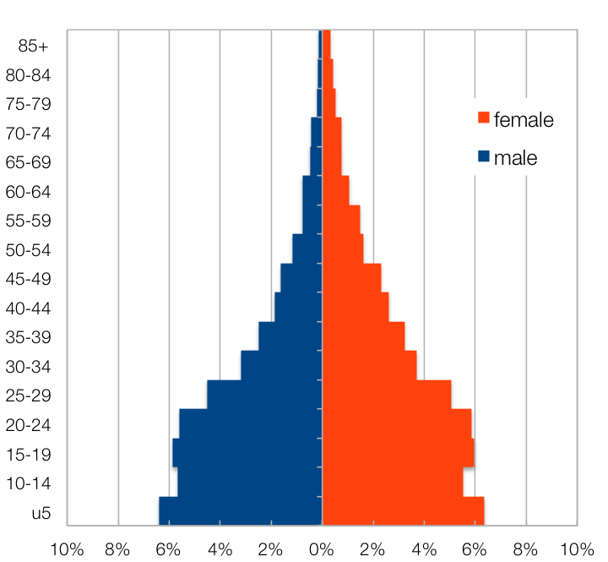

Source: Statistics South Africa, Census 2011 small areas and population database

The zone spans five municipalities in two districts across the two provinces. However, only a tiny portion the Limpopo population is included in the zone (1%), which is nevertheless almost half of Ba-Phalaborwa (42%). In Mpumalanga—Ehlanzeni District—four municipalities are included in the zone and, with the exception of Umjindi, the zone’s population makes up a substantial proportion of each municipality (35% to 40%). The total population in 2016 for the zone is 746,995 (projected from the Census 2011).  **Table** shows the breakdown for each municipality.

The age and gender breakdown of the livelihood zone is given in  **Figure**. The relatively low proportions of adult men seen in many other livelihood zones is not so prevalent here, suggesting that there is less outmigration. There is a high proportion of children (younger than 20).

|  |
| --- |
| Seasonal Calendar |

Since this is a rural livelihood zone and rural life is determined by agricultural seasons, the information is organised by *consumption year*, which begins with the start of the main dry harvest and runs through to just before the next year’s main dry harvest. In this zone, the main dry harvest begins in May, so the consumption year begins that month and runs up until the end of the following April. The livelihood strategies presented in this document also apply to a particular year, one that is neither very good nor bad but occurs most frequently, that is, it is ‘typical’. This is called the *reference year* and the year chosen by participants was 2013-2014, or May 2013 to April 2014.

Figure 4: Seasonal calendar

|  |  |  |  |  |  |  |  |  |  |  |  |  |
| --- | --- | --- | --- | --- | --- | --- | --- | --- | --- | --- | --- | --- |
| Activity | May | Jun | Jul | Aug | Sep | Oct | Nov | Dec | Jan | Feb | Mar | Apr |
| Maize (Land preparation) |  |  |  |  |  |  |  |  |  |  |  |  |
| (Planting) |  |  |  |  |  |  |  |  |  |  |  |  |
| (Weeding) |  |  |  |  |  |  |  |  |  |  |  |  |
| (Harvesting) |  |  |  |  |  |  |  |  |  |  |  |  |
| (Consumption) |  |  |  |  |  |  |  |  |  |  |  |  |
| Vegetables (Land preparation) |  |  |  |  |  |  |  |  |  |  |  |  |
| (Planting) |  |  |  |  |  |  |  |  |  |  |  |  |
| (Weeding) |  |  |  |  |  |  |  |  |  |  |  |  |
| (Harvesting) |  |  |  |  |  |  |  |  |  |  |  |  |
| Farm Employment |  |  |  |  |  |  |  |  |  |  |  |  |
| Off-Farm Employment (CWP) |  |  |  |  |  |  |  |  |  |  |  |  |
| Off-Farm Employment (Tourism) |  |  |  |  |  |  |  |  |  |  |  |  |
| Livestock sales |  |  |  |  |  |  |  |  |  |  |  |  |
| Marula Harvest |  |  |  |  |  |  |  |  |  |  |  |  |
| Hunger Season |  |  |  |  |  |  |  |  |  |  |  |  |
| Collection of Mopani Worms |  |  |  |  |  |  |  |  |  |  |  |  |
| Malaria |  |  |  |  |  |  |  |  |  |  |  |  |
| Livestock Diseases |  |  |  |  |  |  |  |  |  |  |  |  |

The dry harvest is a period for employment and takes place in April. After harvesting, family members engage in employment on commercial farms or vegetable farming until land preparation for the forthcoming main crop season. This begins in spring in October, continues up until December and is accompanied by ploughing and planting, depending on the timing of the rains. Weeding (a period of intense activity and one in which work opportunities increase) takes place from January to April. The main crops grown during this period are maize and a little groundnuts.

Wild foods are collected between December and March, with mopani worm collected from December and marula fruit harvested and brewed in the new year.

|  |
| --- |
| Wealth Breakdown |

Wealth in this livelihood zone is determined primarily by two factors:

1. Employment, a product education and good social connections; and
2. 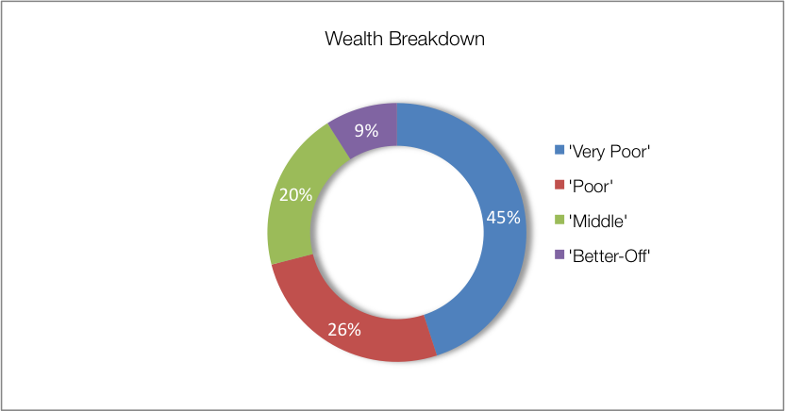Livestock, especially cattle.

Figure 5: Wealth breakdown in the lowveld open access irrigated cropping livelihood zone

|  |  |  |  |  |  |
| --- | --- | --- | --- | --- | --- |
| Category | Item | Wealth Group (typical value in brackets) | | | |
| 'Very poor' | 'Poor' | 'Middle' | 'Better off' |
| Hh Size |  | 6-14 (9) | 5-10 (7) | 5-8 (6) | 4-8 (5) |
| Land (Ha) | Owned | 0.12-1 (0.2) | 0.12-1 (0.3) | 0.12-1 (0.3) | 1-6 (4) |
| Cultivated | 0-1 (0.12) | 0-0.06 (0.03) | 0-½ (½) | ½-6 (4) |
| Livestock (head) | Cattle | 0 | 0-4 (2) | 0-15 (10) | 5-60 (30) |
| Goats | 0 | 0-5 (3) | 5-13 (6) | 6-20 (10) |
| Income | Main | Grants | Grants | Formal employ | Formal employ |
| Annual (R) | 37,700 | 70,500 | 96,600 | 348,200 |

Source: Survey output, 2016

The wealthiest households, described as the ‘better-off’, are those with permanent work and a salary of around R16,600 per month. Households that have lower-paying or less permanent work, which when averaged over the year is approximately R4,000 per month, are referred to as the ‘middle’. Those who do not have any regular employment or business and who depend on grants are described as the ‘poor’ and ‘very poor’; collectively, they are about 71% of households. The ‘very poor’ and ‘poor’ also supplement their grant income with casual labour and other sources.

The amounts of land being cultivated vary with wealth. ‘Better-off’ households have resources from the employment income to take risks and cultivate more land (4 times larger) than those of ‘very poor’ households.

In interviews with village key informants there was a tendency to give larger household sizes, so field teams recorded values in excess to those reported in other surveys, especially the census. The household sizes reported in this analysis were five to nine members, which is larger than the most frequently occurring number of people reported in the census: four people. The larger household sizes are more likely to indicate family groupings (i.e. multiple census households) which can make sense for economic units wherein incomes such as social grants or pensions are shared across census households in the family, labour for cropping and activities is drawn from each census household and so on. These larger ‘households’ or family units are used in the ensuing calculations for sources of food and income—which can be scaled to the appropriate household size from the census.

|  |
| --- |
| Sources of Food |

Sources of food are expressed in terms of contribution to the minimum human food energy needs, which is 8,800 kJ/person/day. Wealthier households may consume considerably more than this, for example 12,232 kJ/person/day, which is 139% of minimum food needs. Some of this consumption may be wasted, for example when food is thrown away or incompletely eaten. Even the poorest households may consume slightly more than the minimum requirement, for example 103%, or 9,064 kJ/person/day.  **Figure** shows the contributions to food energy for each of the main food sources. Bear in mind that the bars *do not* represent quartiles; the numbers of people and households in each wealth group vary considerably.

Figure 6: Sources of food (expressed as percentage of minimum average food energy needs) for each wealth group

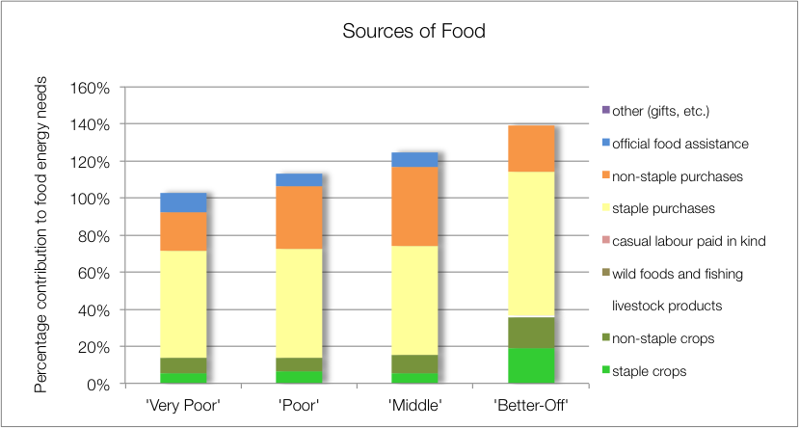

Purchases make up the largest portion of households’ sources of food in all wealth groups. Food purchases contribute 80% to 100% of food energy needs, highlighting households’ dependence on the market in this zone. The contribution to food energy from staple food purchase is 58% for all wealth groups, except the ‘better-off’ for whom it is 78%. The better-off purchase more bread (30% of food needs) and other expensive cereals. Other staple foods are maize (40 to 50% of food energy needs), rice and potatoes. The contribution to food energy from non-staple food purchases increases with wealth, except for the ‘better-off’; starting at 21% for the ‘very poor’ rising to 43% for the ‘middle’. The ‘better off’, however, obtain less of their food energy needs from non-staple purchases (24% of food needs) but they purchase more expensive low-energy foods such as fresh vegetables, meats, etc., instead of beans and sugars.

The contribution from own-produced crops to food energy for ‘better-off’ households is significant (36% of food energy needs). They also gain more food energy from their own-produced non-staples—primarily groundnuts and vegetables. This contributes 17% of their food needs. The other three wealth groups only derive around 15% of their food energy from own crops.

The ‘very poor’, ‘poor’ and ‘middle’ households’ children receive additional food from school lunches, which is included as ‘official food assistance’. Wealthier households tend to send their children to fee-paying schools that do not offer any kind of meals.

|  |
| --- |
| Sources of Cash Income |

Cash incomes vary considerably across wealth groups, with the ‘better-off’ earning R222,510 per annum, more than eight times as much as the ‘very poor’ who earn only R26,340 per annum. **Figure 7** shows this distribution—it must be noted that the bars in the figure are not quartiles, they represent wealth groups and wealth groups are *not* distributed evenly (see **Wealth Breakdown**, above).

The main sources of cash income for in the zone are: formal employment—for the ‘middle’ and ‘better-off’—and cash grants—for the ‘poor’ and ‘very poor’. This is in keeping with surveys that ask for the main cash source.

However, the point of this enquiry was to also gain understanding of how *all* income sources *add up* to make the sources of cash. This is essential because it enables practitioners to link a hazard (such as a price change) to outcomes and it enables other users to see potential areas of intervention. By dividing the value of each source by the total income, we can see these proportions and this is presented in the graph in **Figure 8**.

Grants make up 91% and 67% of the total income for the ‘very poor’ and ‘poor’, respectively. The remainder comes from casual labour (mostly domestic work and agricultural piece work), as well as petty trading.

Figure 7: Sources of annual cash income by wealth group

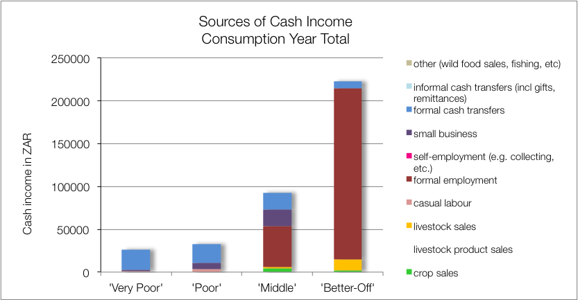

The ‘middle’ and ‘better off’ get their cash from a formal wage or salary for the better part of their income. Some ‘middle’ households may have a member that works seasonally in tourism and earnings typically average to R4,000 per month. The ‘better-off’ tend to have more permanent work, earning around R16,600 per month. The ‘middle’ also gain additional cash from small business activities and petty trading. Crop sales (and a few livestock sales) bring in extra cash for the ‘middle’, while livestock sales (and a few crops) bring in cash for the ‘better-off’. The ‘middle’ and ‘better-off’ also benefit from grants (for example, old age and fostering grants are not means-tested and the probability of a household having a pensioner in it is about one in two—see the population pyramid under **Zone Description**).

Figure 8: Sources of annual cash income as a percentage of total, by wealth group  
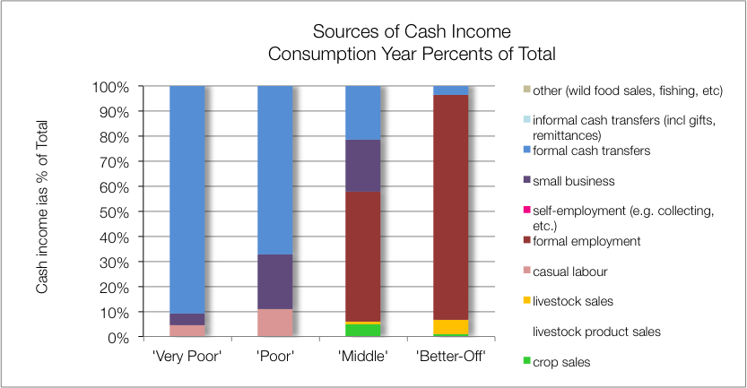

In the Bushbuckridge and Mbombela sections, cropping and livestock are limited by population densities, in Ba-Phalaborwa and Nkomazi it is poor soils and lower rainfall.

|  |
| --- |
| Expenditure |

Absolute expenditures are shown in  **Figure** and this varies across wealth groups in line with incomes. As with income, it is usually more instructive to obtain proportions of total expenditure, as shown in  **Figure**.

Figure 9: Annual cash expenditure, by wealth group  
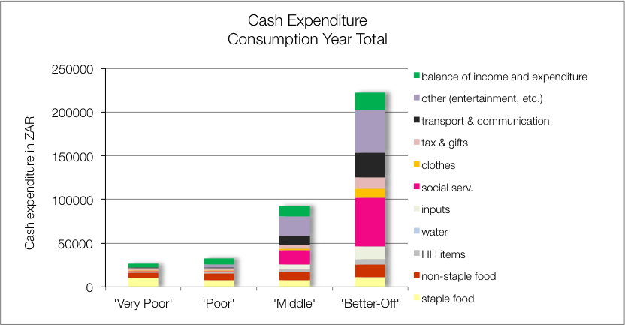

Social services such as health, schooling and taxes occupy a large proportion of expenditure for the ‘middle’ and ‘better-off’ (17% and 25%, respectively). These two groups also spend a greater proportion of their income on agricultural inputs, although it is still quite small, costing only 5% and 7% of the incomes of the ‘middle’ and ‘better-off’, respectively.

The ‘very poor’ and ‘poor’ spend most of their money on food instead, the total food expenditure is 62% and 46%, respectively. The amount they spend on staples is 39% and 23%, respectively.

Figure 10: Annual cash expenditure as a percentage of total, by wealth group  
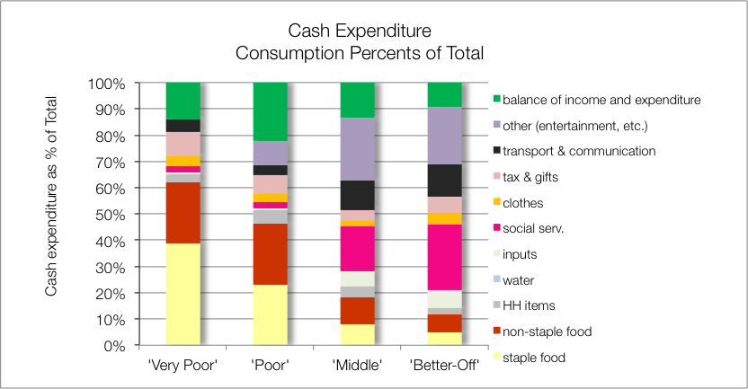

|  |
| --- |
| Hazards, Vulnerabilities and Response Strategies |

Since households are dependent on markets for most of their food, they are most vulnerable to market-related shocks. These ‘market shocks’ may consist of: escalating food prices, eroded grants (for example, when they are not adjusted to match consumer inflation) and job losses.

Drought has an impact, reducing what little crop production that takes place to zero and if severe, it will affect livestock as well. If food prices do not also rise simultaneously with the drought, households can manage crop losses by prioritising more cash to food purchases—this has not happened in the 2015/2016 drought, where food prices rose considerably, by 65% compared with the baseline.

Additional response strategies households may engage in under stress are: switching expenditure, purchasing food on credit, seeking more casual work (usually outside of the village) or selling off assets or belongings. They also make use of drop-in centres for children, although these are only able to support small numbers of children. Some elderly people also request the leftovers from school feeding programmes.

Figure 11: Household food security access scale for the Mpumalanga section of the zone

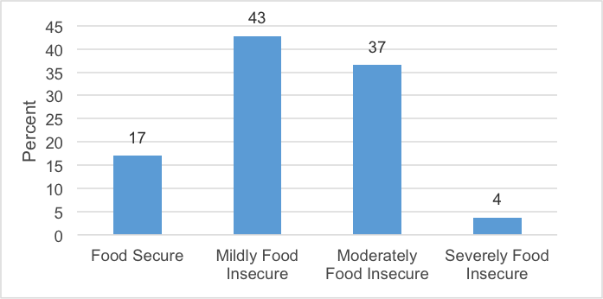

|  |
| --- |
| Food insecurity access scale |

The majority (43 per cent) of the households in this Livelihood Zone were mildly food insecure. This was followed by 37 per cent of the households who were found to be moderately food insecure. Only four per cent of the households were found to be in a severe state of food insecurity. About 17 per cent of the households were food secure in this livelihood zone.

|  |
| --- |
| Household Hunger Scale |

The majority of the households (70 percent) experience no to little hunger and 10 per cent of households had severe hunger in this livelihood zone. Only 19 per cent of the households reported a moderate hunger situation – see  **Figure**.

The majority of households – 84 per cent – were consuming acceptable diets. While 12 per cent of the households were within borderline consumption pattern, four per cent of the households were consuming poor diets.

Figure 13: Food Consumption Scale in the Mpumalanga section of the zone

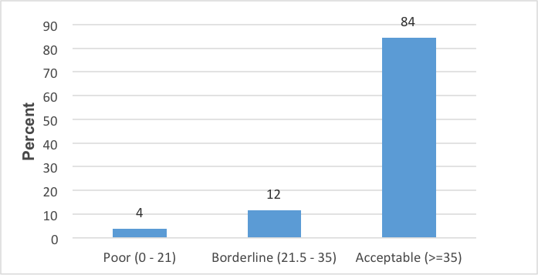

Figure 12: Household hunger scale in the Mpumalanga Province section of the zone

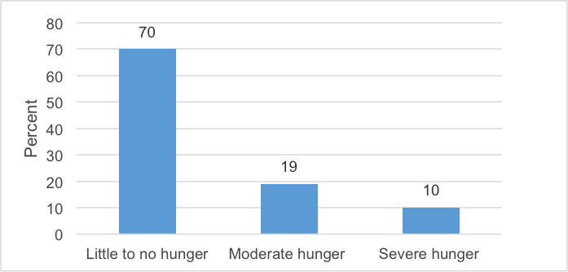

Figure 14: Prevalence of severe and moderate acute malnutrition in the Mpumalanga section of the zone

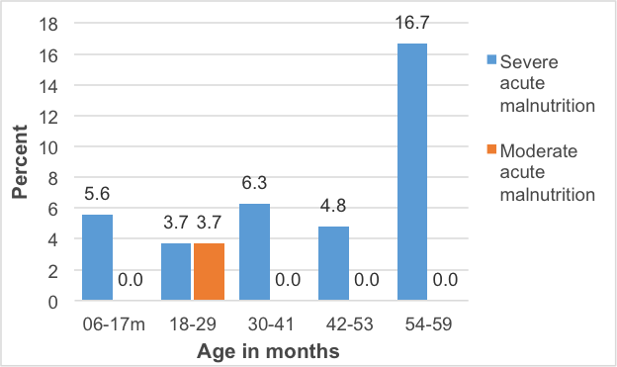

Figure 15: Prevalence of stunting in the Mpumalanga section of the zone

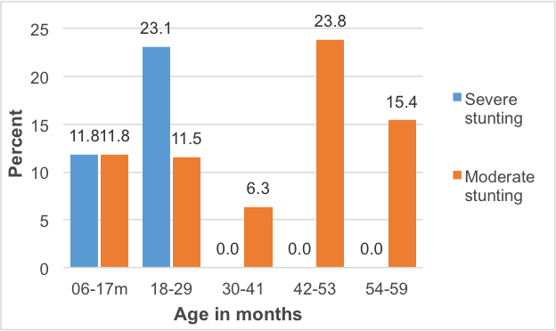

Figure 16: Prevalence of underweight children in the Mpumalanga section of the zone

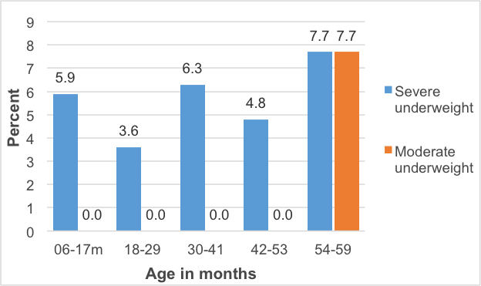

|  |
| --- |
| Nutrition and Anthropometry |

In general, the under-five children of all age groups were severely acutely malnourished. Severe acute malnutrition is predominant in the 54-59 months old children in the livelihood zone ( **Figure**). About 17 per cent of the under-five children in the age group of 54-59 months old were severely acutely malnourished. Moderate acutely malnourished under-five children were only found in the age group of 18-29 months old.

There is a high prevalence of severe among under-five children within 18-29 months of age and moderate stunting among under-five children of 42-53 months old ( **Figure**). The under-five children of all age groupings were moderately stunted while the severe stunted children were only within the ages of 6-17 months old and 18-29 months old. No severe stunting was observed in age groups of 30-41, 42-53 and 54-59 months old in this livelihood zone.

Severe underweight was observed among under-five children of all age groupings. No moderate underweight was observed except among the children of under-five in the ages of 54-59 months old. About eight per cent of the under-five children were moderately underweight, while another eight per cent of the under-five children of the same age group were found to be severely underweight.

|  |
| --- |
| Conclusions and Recommendations |

This livelihood zone lacks suitable conditions for crop farming and is highly populated, which makes raising livestock difficult as well. Crop farming yields could be improved through greater service provision and market support, though crops are constrained by environmental factors. This increased productivity will unlikely benefit all but a few households directly, but will create additional new possibilities through increased work opportunities. For many 'poor' and 'very poor' households, grants will remain the main source of income for some time to come.

Figure 17: Detailed map of the Limpopo section of the livelihood zone showing the sampled sites, other livelihood zones, administrative areas down to enumeration small areas, and infrastructure

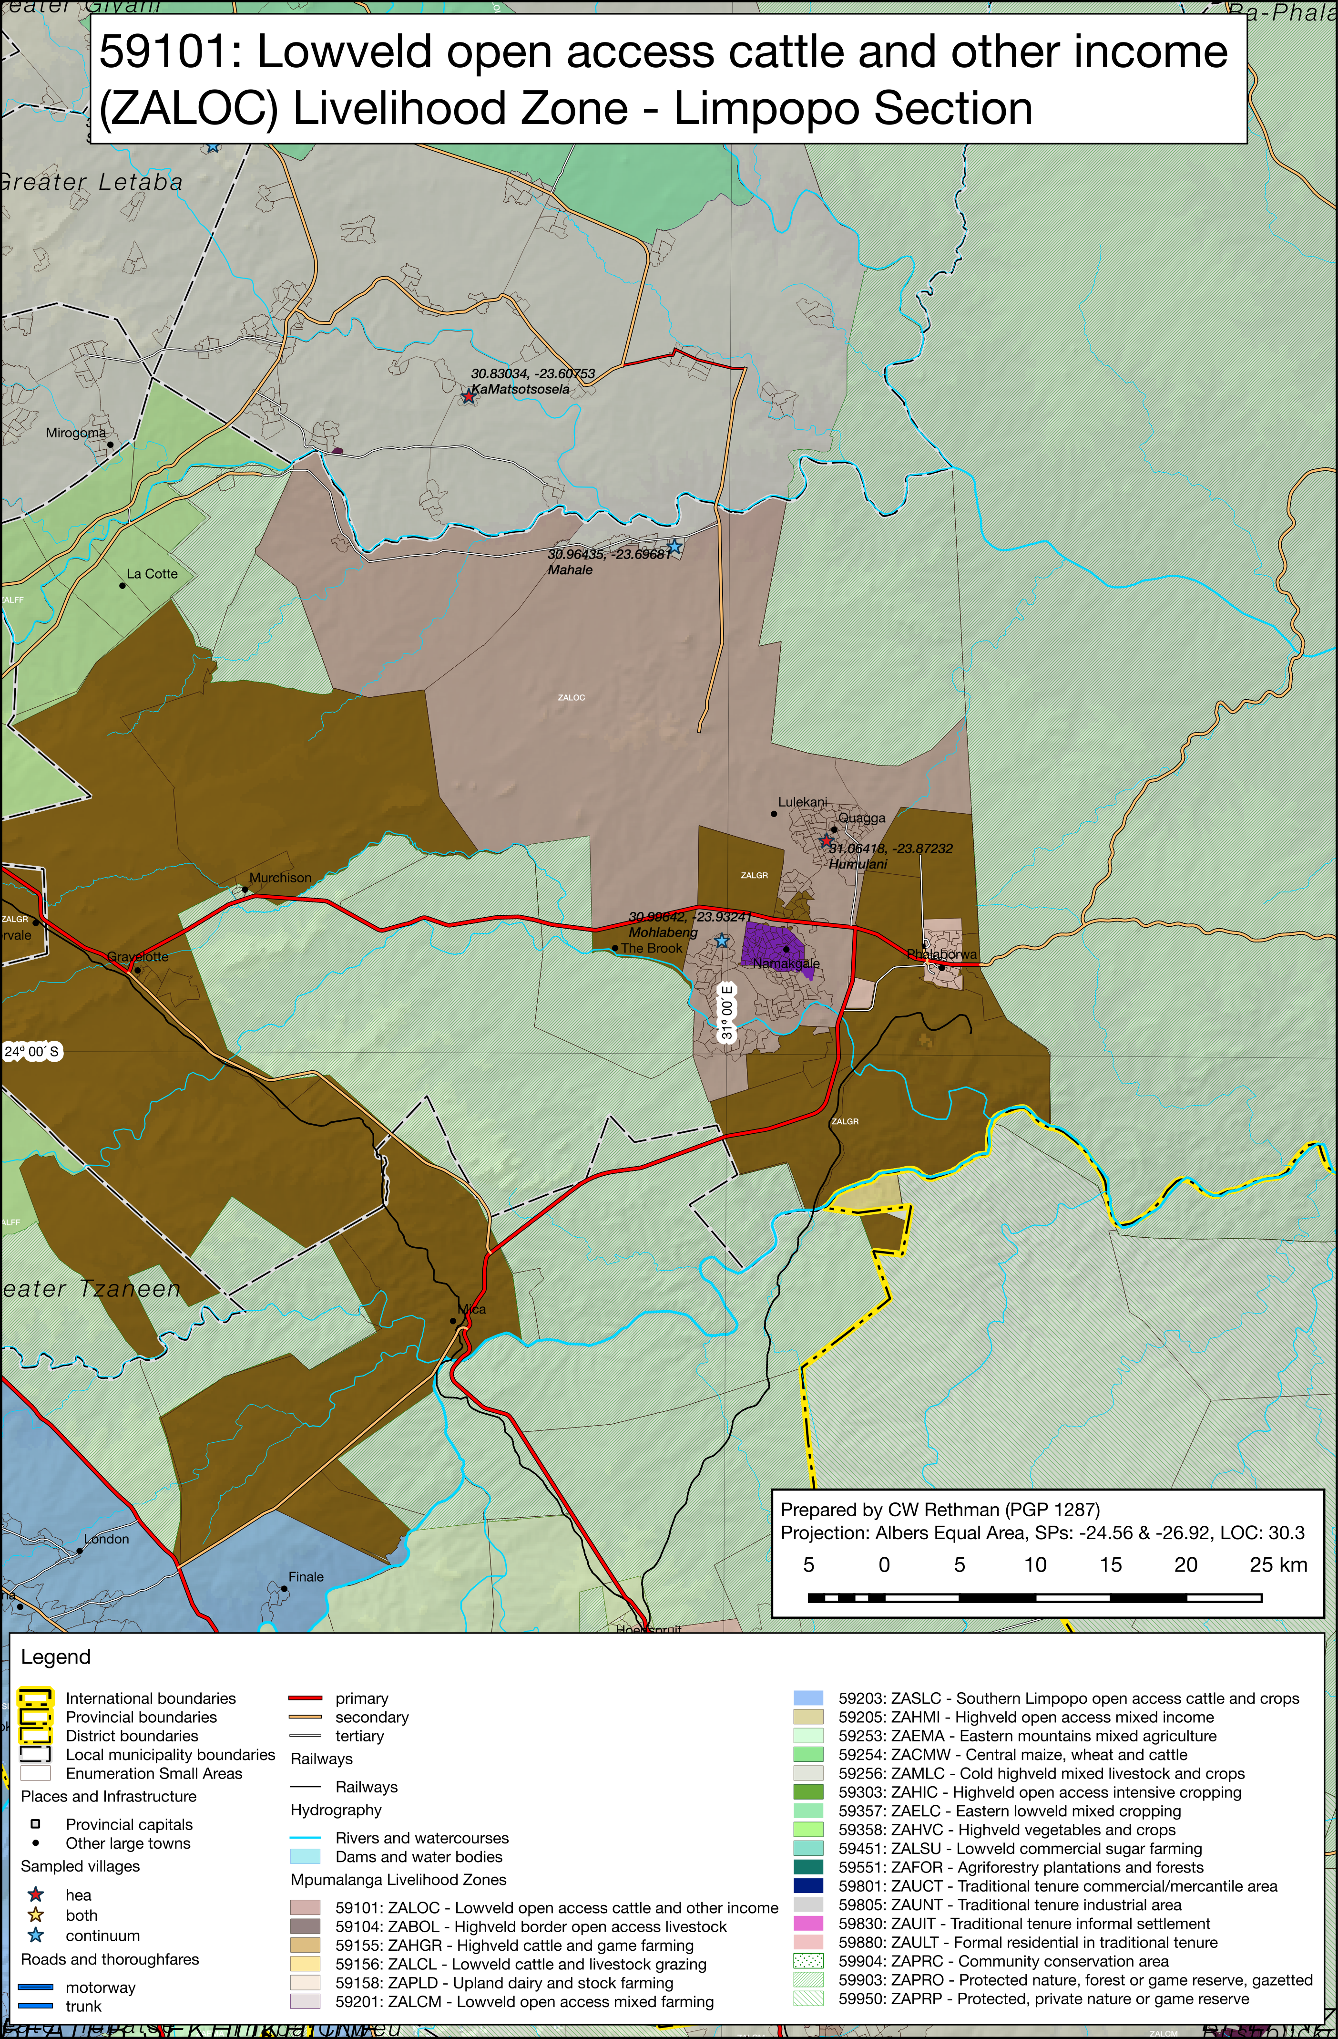

Figure 18: Detailed map of the Mpumalanga section of the livelihood zone showing the sampled sites, other livelihood zones, administrative areas down to enumeration small areas, and infrastructure

